Project Vision

**Conducting an Interview**

* Appear professional
* Record all information
* Separate facts from opinion
* Give interviewee time to ask questions

**Interview Practical Tips**

* Don’t worry be happy
* Pay attention
* Be honest
* Summarize key points

**Post Interview Follow Up**

* Prepare interview notes
* Prepare interview report
* Look for gaps in questions

**Vision**

* Used in both agile and non-agile world.
* Used to answer:
  + What problem will the system solve?
  + What features and benefits will it provide?
  + Who does it provide it for?
  + What performance, reliability, etc. will it deliver?

**Project Constraints**

* Constraints are outside of your control
* Imposed by client, organization or government
* 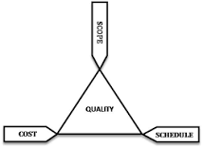3 main types:
  + Cost
  + Time
  + Scope